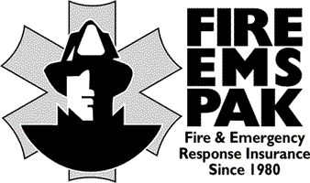
FIRE/EMS-PAK
SPECIAL EVENTS - SURVEY
FOOD

Name of Insured: City/State: Policy #

Food serving can result in a costly claim. It is important to have someone watching the food at all times to make sure it is prepared and served correctly.

1. Will you be serving food? Yes No. Will any food be made by your members? Yes No.
If yes, list types of food made by your members?

2. What other foods will be served that are not made by your members?

3. In preparing & servicing food, some form of head covering should be worn to prevent hair from falling into the food. Will you do this? Yes No.

4. In preparing & servicing food, some form of plastic gloves should be worn? Will you do this?
Yes No.

5. Will you keep all food from direct sunlight to avoid food poisoning? Yes No

6. Foods that are not to be served hot, are to be kept cool at all times. Place this food on top of ice. Will you do this? Yes No.

7. Will you be serving raw meat? Yes No. Will this be kept on ice at all times? Yes No.

8. Will independent vendors be preparing and serving food? Yes No. If yes, obtain a certificate from each vendor and forward a copy to your insurance agent.

Date Signature of Insured’s Representative

